**Experiment NO: 0 1**

**Name of Experiment: Scan conversion of a point.**

**Source Code:**

#include<graphics.h>

#include<conio.h>

#include<bits/stdc++.h>

using namespace std;

int main()

{

int gd = DETECT, gm;

initgraph(&gd, &gm, "C:\\TC\\BGI");

float x = 200, y = 200;

putpixel (x, y, WHITE);

getch();

closegraph();

return 0;

}

**Output:**

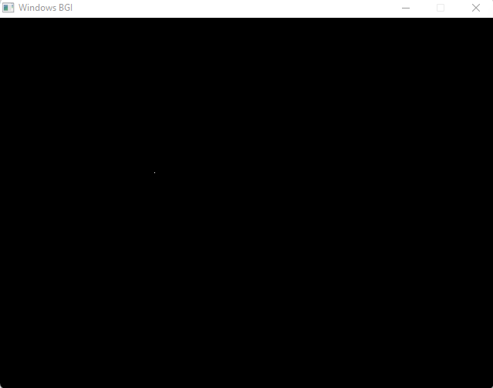

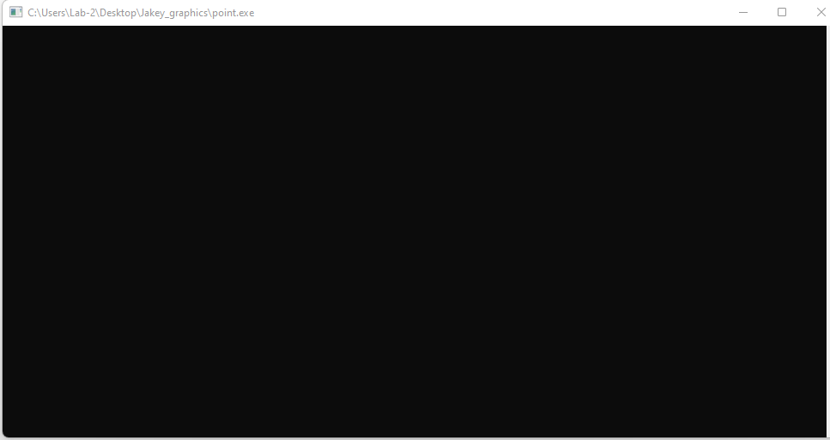

**Experiment N0 : 0 2**

**Name of Experiment: Scan Conversion of a line using DDA Algorithm**

**Source Code:**

#include<graphics.h>

#include<conio.h>

#include<stdio.h>

int main()

{

int gd = DETECT ,gm, i;

float x, y,dx,dy,steps;

int x0, x1, y0, y1;

initgraph(&gd, &gm, "C:\\TC\\BGI");

setbkcolor(WHITE);

x0 = 100 , y0 = 200, x1 = 500, y1 = 300;

dx = (float)(x1 - x0);

dy = (float)(y1 - y0);

if(dx>=dy)

{

steps = dx;

}

else

{

steps = dy;

}

dx = dx/steps;

dy = dy/steps;

x = x0;

y = y0;

i = 1;

while(i<= steps)

{

putpixel(x, y, WHITE);

x += dx;

y += dy;

i=i+1;

}

getch();

closegraph();

}

**Output:** 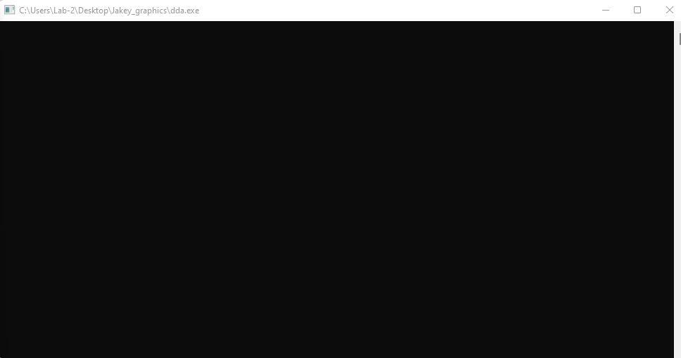

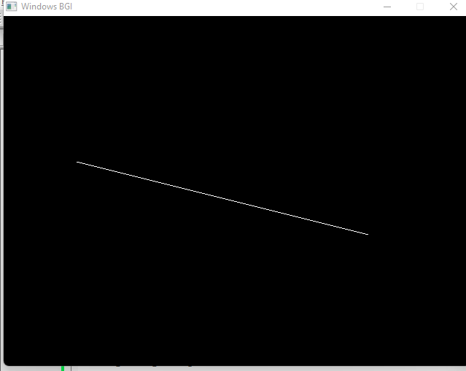

**Experiment NO : 03**

**Name of Experiment: Scan Conversion of line using Bresenham Algorithm**

**Source Code:**

#include<stdio.h>

#include<graphics.h>

#include<bits/stdc++.h>

void drawline(int x0, int y0, int x1, int y1)

{

int dx, dy, p, x, y;

dx=x1-x0;

dy=y1-y0;

x=x0;

y=y0;

p=2*dy-dx;

while(x<x1)

{

if(p>=0)

{

putpixel(x,y,7);

y=y+1;

p=p+2*dy-2*dx;

}

else

{

putpixel(x,y,7);

p=p+2*dy;}

x=x+1;

}

}

int main()

{

int gd = DETECT, gm;

initgraph(&gd, &gm, "C:\\TC\\BGI");

int error, x0, y0, x1, y1;

// initgraph(&gdriver, &gmode, "c:\\turboc3\\bgi");

printf("Enter co-ordinates of first point: ");

scanf("%d%d", &x0, &y0);

printf("Enter co-ordinates of second point: ");

scanf("%d%d", &x1, &y1);

drawline(x0, y0, x1, y1);

getch();

return 0;

}

**Output:**

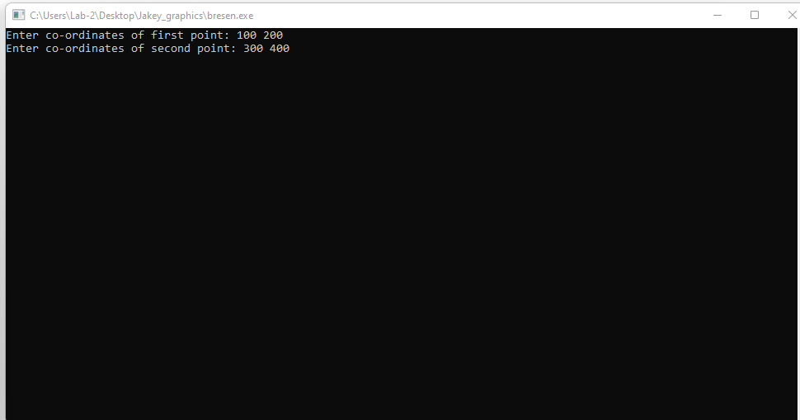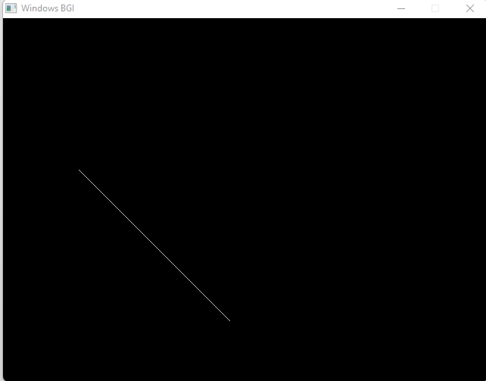

**Experiment No : 04**

**Name of Experiment: Scan Conversion of circle using bresenhen Algorithm**

**Source Code:**

#include <graphics.h>

#include <stdlib.h>

#include <stdio.h>

#include <conio.h>

#include <math.h>

void EightWaySymmetricPlot(int xc,int yc,int x,int y)

{

putpixel(x+xc,y+yc,RED);

putpixel(x+xc,-y+yc,YELLOW);

putpixel(-x+xc,-y+yc,GREEN);

putpixel(-x+xc,y+yc,YELLOW);

putpixel(y+xc,x+yc,12);

putpixel(y+xc,-x+yc,14);

putpixel(-y+xc,-x+yc,15);

putpixel(-y+xc,x+yc,6);

}

void BresenhamCircle(int xc,int yc,int r)

{

int x=0,y=r,d=3-(2*r);

EightWaySymmetricPlot(xc,yc,x,y);

while(x<=y)

{

if(d<=0)

{

d=d+(4*x)+6;

}

else

{

d=d+(4*x)-(4*y)+10;

y=y-1;

}

x=x+1;

EightWaySymmetricPlot(xc,yc,x,y);

}

}

int main(void)

{

/* request auto detection */

int xc,yc,r,gdriver = DETECT, gmode, errorcode;

/* initialize graphics and local variables */

initgraph(&gdriver, &gmode, "C:\\TURBOC3\\BGI");

/* read result of initialization */

errorcode = graphresult();

if (errorcode != grOk) /* an error occurred */

{

printf("Graphics error: %s\n", grapherrormsg(errorcode));

printf("Press any key to halt:");

getch();

exit(1); /* terminate with an error code */

}

printf("Enter the values of xc and yc :");

scanf("%d%d",&xc,&yc);

printf("Enter the value of radius :");

scanf("%d",&r);

BresenhamCircle(xc,yc,r);

getch();

closegraph();

return 0;

}

**Output:**

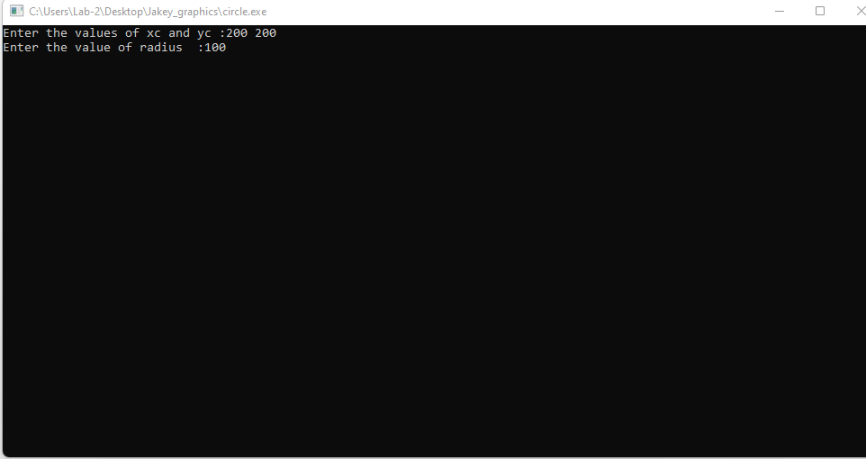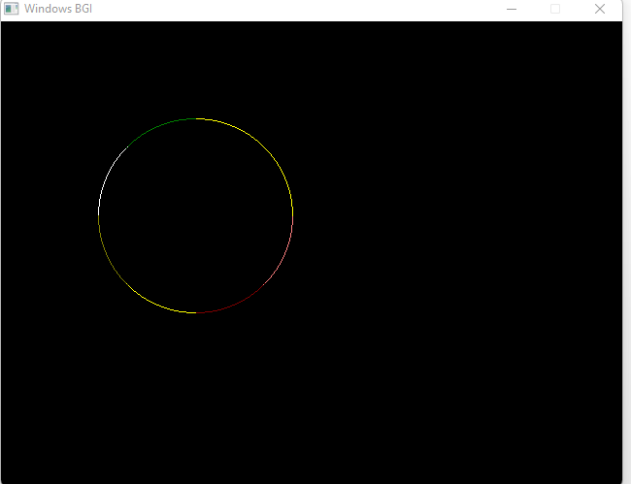

**Experiment No : 05**

**Name OF Experiment : Scan Conversion OF an Ellipse**

**Source Code of Ellipse:**

#include <iostream>

#include <graphics.h>

void plotEllipsePoints(int xc, int yc, int x, int y)

{

putpixel(xc + x, yc + y, WHITE);

putpixel(xc - x, yc + y, WHITE);

putpixel(xc + x, yc - y, WHITE);

putpixel(xc - x, yc - y, WHITE);

}

void drawEllipse(int xc, int yc, int rx, int ry)

{

int x = 0;

int y = ry;

int rxSq = rx * rx;

int rySq = ry * ry;

int twoRxSq = 2 * rxSq;

int twoRySq = 2 * rySq;

int p;

int px = 0;

int py = twoRxSq * y;

plotEllipsePoints(xc, yc, x, y);

p = rySq - (rxSq * ry) + (0.25 * rxSq);

while (px < py)

{

x++;

px += twoRySq;

if (p < 0)

{

p += rySq + px;

}

else

{

y--;

py -= twoRxSq;

p += rySq + px - py;

}

plotEllipsePoints(xc, yc, x, y);

}

p = rySq * (x + 0.5) * (x + 0.5) + rxSq * (y - 1) * (y - 1) - rxSq * rySq;

while (y > 0)

{

y--;

py -= twoRxSq;

if (p > 0)

{

p += rxSq - py;

}

else

{

x++;

px += twoRySq;

p += rxSq - py + px;

}

plotEllipsePoints(xc, yc, x, y);

}

}

int main()

{

int gd = DETECT, gm;

initgraph(&gd, &gm, "");

int xc = 250; // X-coordinate of the center of the ellipse

int yc = 250; // Y-coordinate of the center of the ellipse

int rx = 150; // X-radius of the ellipse

int ry = 100; // Y-radius of the ellipse

drawEllipse(xc, yc, rx, ry);

delay(5000);

getch();

closegraph();

return 0;

}

**Output :**

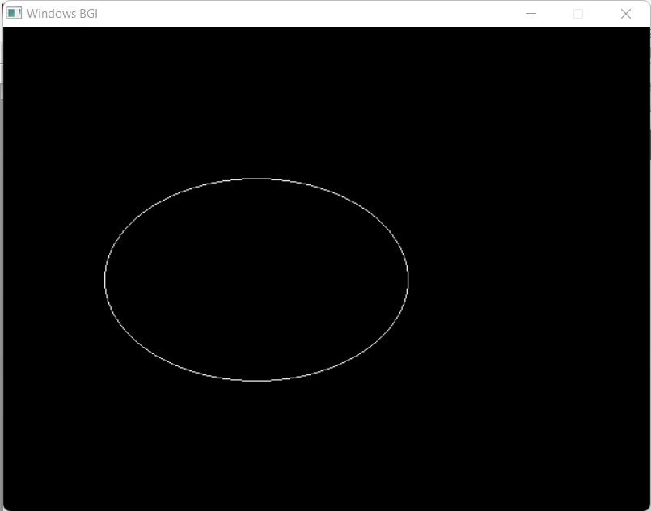

**Experiment No : 06**

**Name OF Experiment : Scan Conversion a Circle using Mid-Point Algorithm**

**Source Code of Circle(Mid-Point):**

#include <iostream>

#include <graphics.h>

using namespace std;

void drawCircle(int xc, int yc, int radius) {

int x = 0;

int y = radius;

int p = 1 - radius;

while (x <= y) {

putpixel(xc + x, yc + y, WHITE);

putpixel(xc + y, yc + x, WHITE);

putpixel(xc - x, yc + y, WHITE);

putpixel(xc - y, yc + x, WHITE);

putpixel(xc + x, yc - y, WHITE);

putpixel(xc + y, yc - x, WHITE);

putpixel(xc - x, yc - y, WHITE);

putpixel(xc - y, yc - x, WHITE);

x++;

if (p < 0) {

p += 2 * x + 1;

} else {

y--;

p += 2 * (x - y) + 1;

}

}

}

int main() {

int xc, yc, radius;

cout << "Enter center coordinates (xc and yc): ";

cin >> xc >> yc;

cout << "Enter radius: ";

cin >> radius;

int gd = DETECT, gm;

initgraph(&gd, &gm, "");

drawCircle(xc, yc, radius);

getch();

closegraph();

return 0;

}

**Output:**

